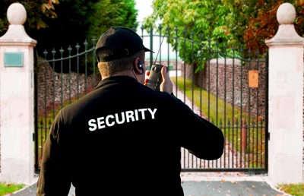
We are looking for personnel to fill ARMED security positions at a business in the Easton area of Columbus, Ohio and at a PRIVATE residence in Southern Delaware County. Join Direct Approach Tactical Solutions, LLC. for a part-time position to assist in supplementing your retirement. We are hiring for all shifts, 24 hour coverage 7 days a week. Schedules will be flexible and will have rotating weekends off. State certification and licensing procees is paid for upon hiring.
Starting pay will be $25 an hour for onsite security and if personal security is required that will be compensated at $35-$60 an hour. Utilization of your personally owned firearm is approved and uniforms will be provided.

For information contact Brandon Cruz @ Direct Approach Tactical Solutions, LLC at (614) 989-1637 or E-mail: Bcruz910@gmail.com
Now HIRING

RETIRED/FORMER/CURRENT Law Enforcement Officers/Certified OPOTC Military.
- PARTIME EMPLOYMENT
24 to 36 hours a week

- COMPETATIVE COMPENSATION
$25 an hour for residential security and monitoring

$35-$60 an hour for personal security when required

Possible End of year $500 Bonus
(based on experience)

- UNIFORM and VEHICLES PROVIDED

- ALL SHIFTS OFFERED BASED ON AVAILABILITY

Direct Approach Tactical Solutions
www.directapproachtactical.com
6783 Clear Creek Loop, Powell, Ohio 43065 Tel 614.669.5615

Private Security

