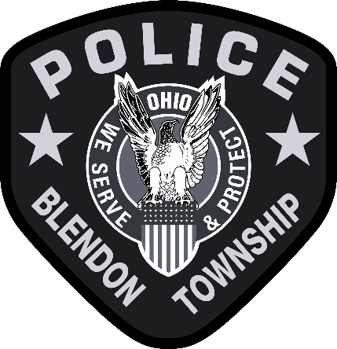
Class Title: Police Officer
Bargaining Unit: Police
Class Code: Full Time
Salary: $84,155-$105,366

NATURE OF WORK
Under the direction of a sergeant, has responsibility to enforce all local, state and federal laws
within Blendon Township, Franklin County, Ohio. Performs other duties as assigned.
SUPERVISION
Work is performed under the direction of a sergeant. Work is performed within the guidelines of
department general orders with some discretion in enforcement of local, state, and federal laws.
Work is reviewed daily by supervisors through reports and performance evaluations

ESSENTIAL FUNCTIONS OF WORK (May not include all duties performed.)
• Ability to operate department vehicles and equipment.
• Patrols the community on foot, or in police cars protecting persons and property.
• Enforces all state laws and township resolutions.
• Investigates complaints, interviews suspects and witnesses.
• Responds to emergency calls for assistance. Performs criminal and vehicle crash
investigations.
• Performs traffic enforcement duties.
• Performs routine security inspections.
• Conducts searches and seizures.
• Completes detailed written reports.
• Makes arrests when necessary.
• Uses firearms as necessary.
• Maintains all equipment necessary for the daily performance of job duties.

MINIMUM REQUIREMENTS OF WORK
• Must possess a high school diploma or GED.
• Must be at least 18 years of age at the time of hire.
• Must successfully complete a comprehensive background investigation including
criminal, controlled substances, credit, driving, work history, and physical fitness testing.
• Background must be free of prior felony convictions.
• Legally able to possess a firearm.
• Legally eligible to work in the United States of America.
• Both eyes must be correctable to 20/20 vision and no color blindness.
• Must possess a valid State of Ohio Motor Vehicle Operator's License free from
excessive violations.
• Must have successfully passed all qualifying examinations and completed the Ohio
Peace Officer Training Academy.
• Knowledge of first aid and CPR.
• Effective oral and written communication skills in the English language.
• Ability to maintain accurate records and prepare reports.
• Ability to communicate and manage the public under a variety of circumstances.
• Ability to work a varied schedule on a variety of shifts.

BENEFITS
• Health, dental, vision, and prescription drug insurance plans.
• Ohio Public Employees Retirement System.
• Sick/Vacation/Holiday Pay.
• Uniform and equipment allowance.

